Logging On

To get started, click the link provided to you by the organization’s site administrator. This will take you to the Logon Page. The site administrator has created an account for you, so you will only need to set your password before you can logon.

- If this is your first time here, click Forgot Your Password to securely set your password.
  - Going forward, you may enter your logon credentials and click Logon.
  - Do not click Create New Account, as that option is for applicants only.
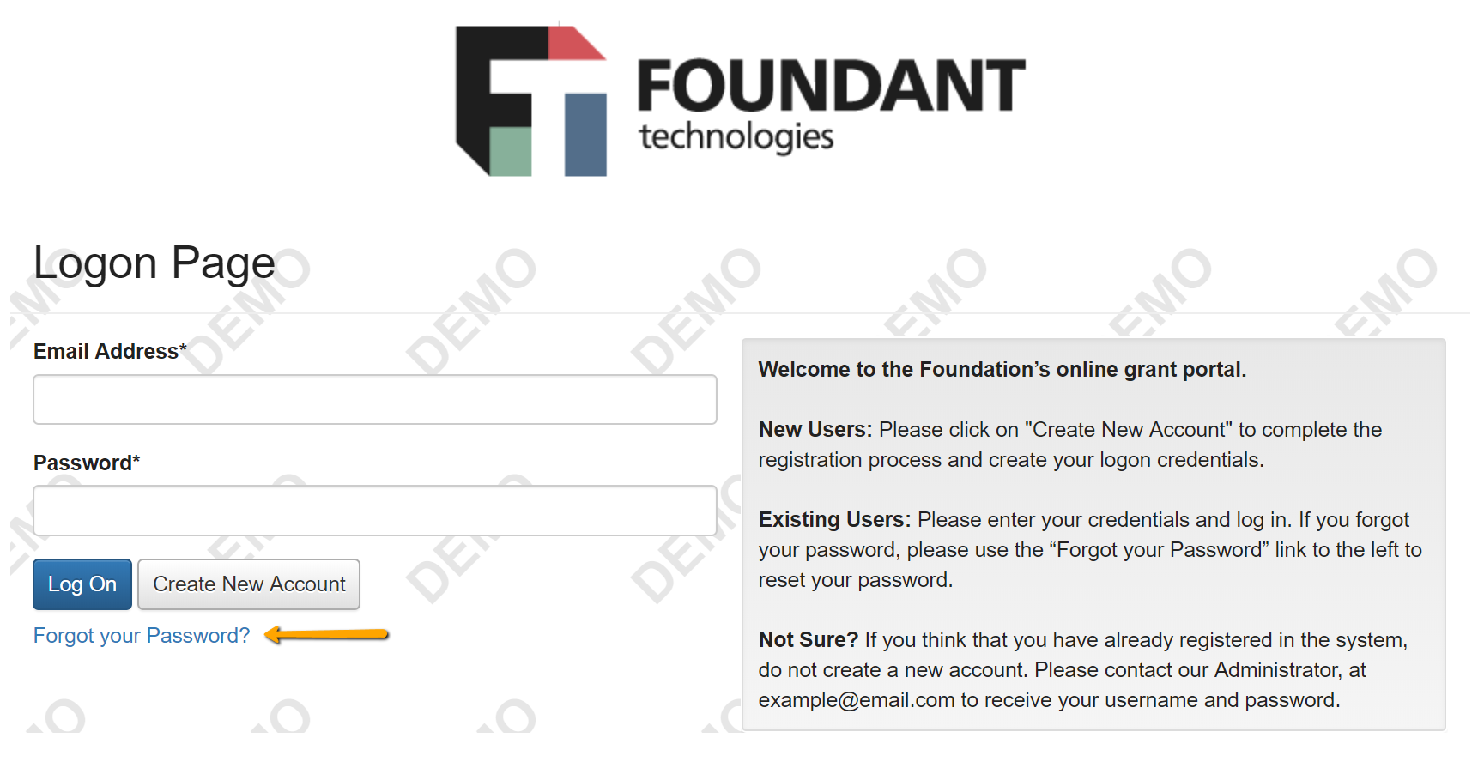
- After logging on, you will land on your dashboard.

Your Dashboard

Your dashboard displays all evaluations assigned to you. You can always return here by clicking the Home Icon in the top navigation bar.

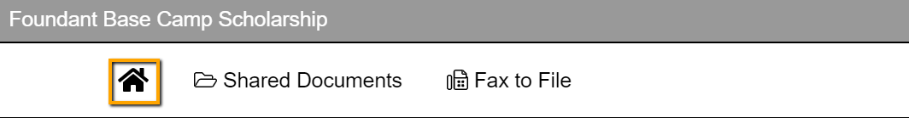

At the top of the page is a visual representation of your assigned evaluations.

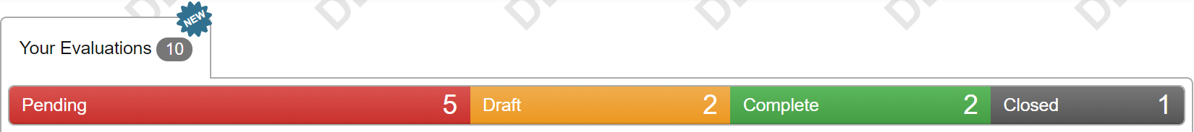

Clicking a status in this bar will filter your list to only show evaluations in that status. Clicking the status again will remove the filter.

Below the status bar is the list of your assigned evaluations.
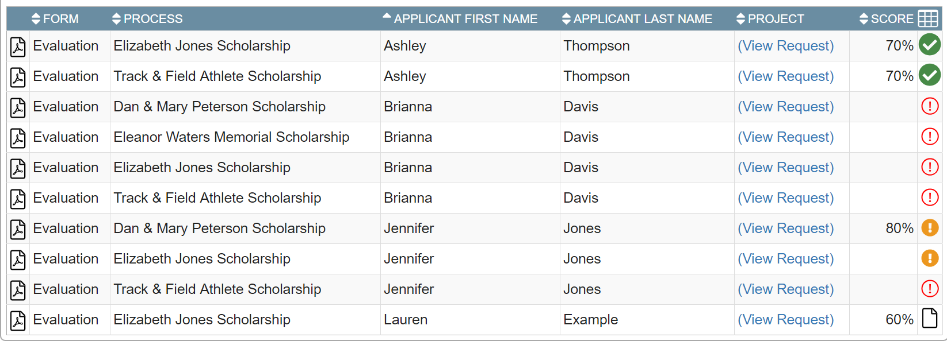
  - The columns in this table can be sorted (i.e. by applicant or by scholarship) by clicking on the column header.
  - The Review Icon (in the farthest column to the right), indicates the status of each evaluation:
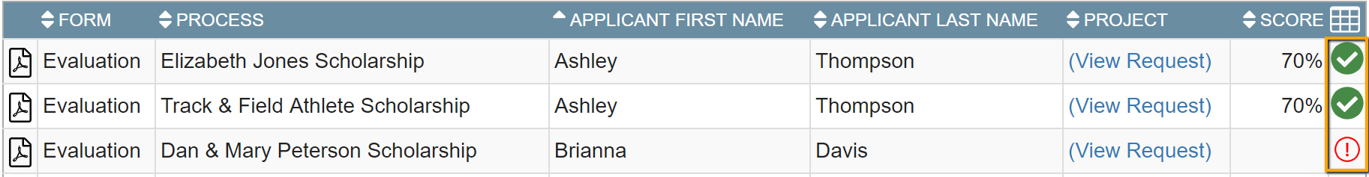

(NOTE: Since you will only be viewing applications, the items referring to evaluations do not apply)

